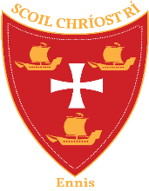
Scoil Chríost Rí Calendar 2025/2026

School Reopening | Thursday 26th June 2025
Presidential Election | Expected School closing Friday October 24th
Halloween | Monday 27th October – Friday 31st October
Staff Training | Monday December 8th Child protection  Tuesday 9th NCSE Whole school training
Christmas | Monday 22nd December – Friday 2nd January 2026  (School will close at 12pm on Friday 19th December)
St Bridget’s Day | Monday 2nd February
Mid Term Break | Thursday 19th & Friday 20th February
Staff Training | Tuesday 24th February
St Patrick’s Day | Monday 16th & Tuesday 17th March
Easter | Monday 30th March – Friday 10th April  (School will close at 12pm on Friday 27th March)
May Bank Holiday | School closed Friday 1st May, Monday 4th & Tuesday 5th
Staff Training | Monday 18th May
June Bank Holiday Weekend | School closed Friday 29th May & Monday 1st June
Summer | Friday 26th June  (School will close at 12:00pm)

